Notes for Building of TTC Web-Site

The goal of TTC (Table Tennis Club) is to create an interest in Table Tennis in the College for all students & Staff.

Home Page:

Firstly we decided on a template for the Home and subsequent pages (Please see attached document titled “Template for Home Page”. We accessed several sites looking for inspiration & opted to base our site loosely on the Florida State University Table Tennis Club site http://www.fsu.edu/~activity/tabletennis/fun.html.

The home page will contain the following:

An introduction to Table Tennis and the goals of the Club.
The rules of Table Tennis (Scoring etc.)
The benefits of playing Table Tennis as means to keep fit & socialise.
A link to a page for people interested in joining
Links to sports shops specialising in Table Tennis equipment & outfits
A link to a page containing top tips from a Table Tennis Professional

Building the Site:

Then we set about building the site, this was done firstly using standard html tags for style, font etc. & this was very close to the original template.

CSS
Once CSS was introduced we had to re-organise the site to ensure the various styling elements were controlled by CSS.

Most of these were done using an external style sheet called TTCStyle.css, with the exception of Banner which required a different background to the graded one of the other pages. This was achieved with an internal style.

Images
In order to achieve the graded background we created a graded image in word which was then imported into MS Paint, this image was then saved as a jpeg image which we could use for the graded effect.

All images were placed in the Project Images folder with the exception of the “ball.gif” image which was used for the bullets in the un-ordered list. This was because the CSS styling element wouldn’t function properly with this image in the images folder.

Javascript

For javascript elements we used the form validation script provided in class which was then applied to our application form page, we inserted a date & time into the Banner page which were both internal scripts. We then used an external script to insert a Welcome Cookie into the site. This script uses a box to ask the user their name & then welcomes them by name every time they return to the main page.

Javascript uses:
Welcome Cookie (external)
Constant Clock & Date (internal in Body)
Form validator (internal in Head)

Other Browsers

We tested the web-site in Firefox and Safari browsers and it worked well with all the functions working properly however there were some differences in the display of the pages & the proportions of certain features. This also occurred when the site was displayed on different sized screens.

Site Displayed on IE Site Displayed on Firefox

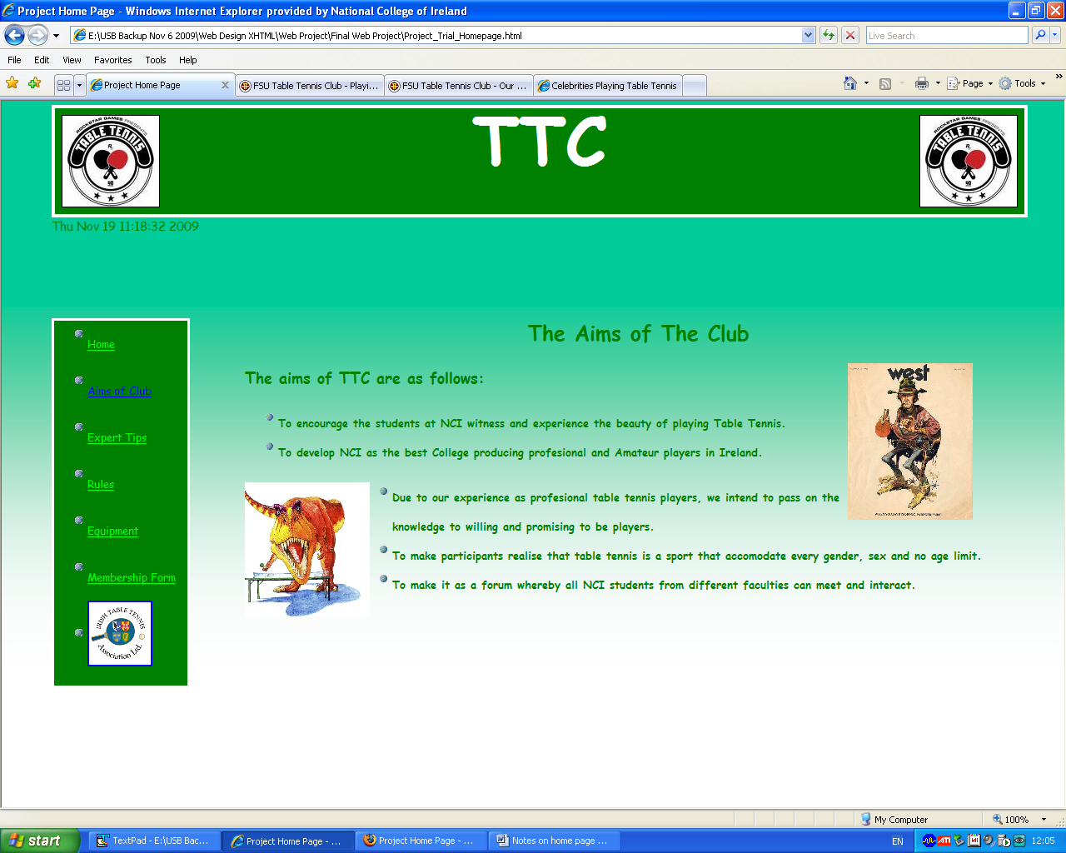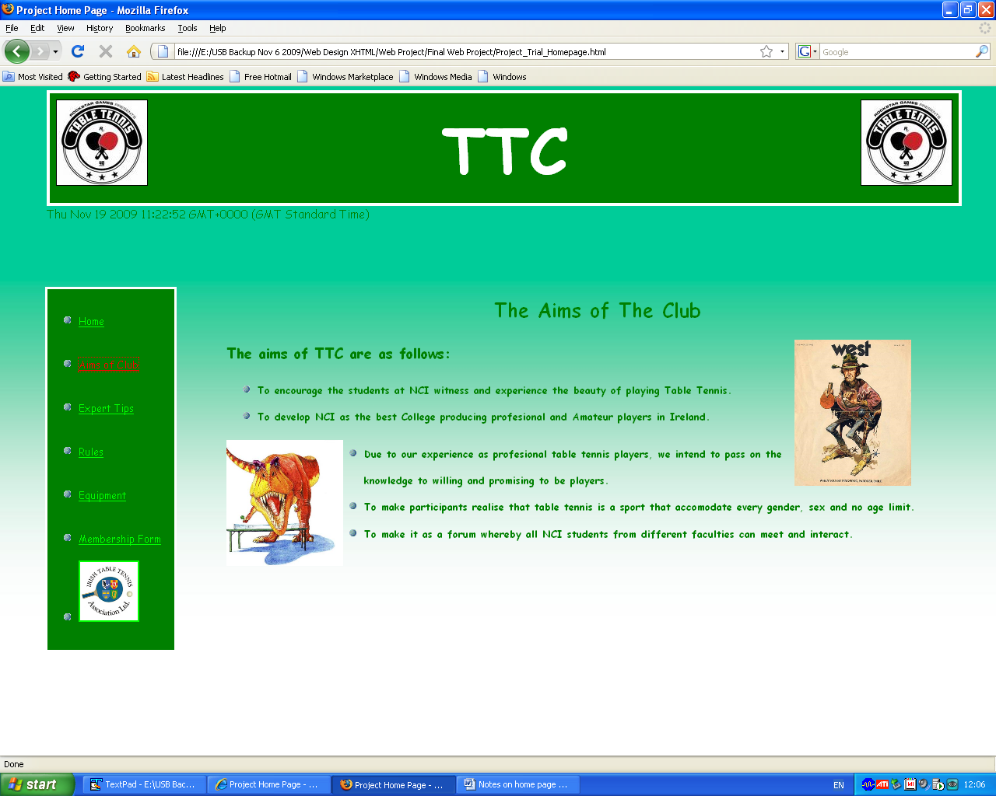

Validation

xhtml

When it came to validation, we had almost 100% success with Transitional however on the Frameset page we ran into a problem with the “Border “0”” attribute. This was unacceptable to the validator however we chose to leave the border at 0 for aesthetic reasons.

css

Css validated 100% but with warnings concerning the colour of text being the same as some backgrounds. This was deliberate on our behalf & didn’t cause any problems

Bibliography

Images

Pavarotti, Gates, Eastwood, T.Rex all sourced from ‘Celebrities Playing Table Tennis’, accessed Oct. 7th 2009, from http://www.larrytt.com/celebrities_playing_tt/.

Graphics

Clipart.

Websites

Name unknown, 2009, “Table Tennis for competition and leisure time”, www.tabletennis-sportmadison.com/index.htm, accessed 12 November 2009, from http:// www.tabletennis-sportmadison.com/index.htm

Name unknown, 2007-2009, “Table Tennis Equipment”, www.tabletenniszone.com/, accessed 11 November 2009, from http:// www.tabletenniszone.com/

Name unknown, 2008, “Sports| Fitness| Equipment Retailer-Mcsport”, www.mcsport.ie, accessed 29 October 2009, from http:// www.mcsport.ie

Name unknown, 2009,”Table Tennis Equipment”, www.milletsport.co.uk, accessed 01 November 2009, from http:// www.milletsport.co.uk/table-tennis

